**North South University**



**Department of ELECTRICAL AND COMPUTER SCIENCE**

**Report on Economic and Social Impact of the Project**

**COURSE: CSE-499-B**

**SECTION-12**

**GROUP-1**

PROJECT TITLE: GARBAGE COLLECTOR ROBOT

Supervised BY: Dr. Shazzad Hosain

**SUBMITTED BY-**

|  |  |
| --- | --- |
| **NAME** | **ID** |
| **FARJANA ALAM** | **1620060042** |
| **MOIN SHAHRIYAR** | **1610586042** |
| **SARHAN OSMAN BHUIYA** | **1611008042** |

**WEEKLY PROJECT PROGRESS PLAN**

|  |  |
| --- | --- |
| DATE | Work Details |
| Week - 1  30-09-2019 | Collect all required equipment. (robotic arm for grabbing object, customized metallic car) |
| Week - 2  14-10-2019 | Design the primary structure of full project. |
| Week - 3  21-10-2019 | Assemble the robotic arm with code and calculation for grabbing garbage. |
| Week - 4  28-10-19 | Initial test of the car by powering it up. Check whether it can take the load(weight) or not. Additionally calculate all the power consuming devices based on that select proper power supply. |
| Week - 5  04-11-2019 | Combine robotic arm and car. Also test the primary mechanism. |
| Week - 6  11-11-2019 | Make connection with the the raspberry pi and camera to detect garbage. |
| Week - 7  18-11-2019 | Add sensors (sonar) for object avoidance so that the car can move without any interrupt. |
| Week - 8  25-11-19 | After classifying the garbage type check the basket can rotate correctly to gather garbage at a specific potion of basket |
| Week-9+10  02-12-2019 | Testing…  (Test the project to check all the feature of the project working accurately) |

**ABSTRACT**

We are presenting a smart robot that could present a viable solution towards efficient waste management which is based on embedded, digital image processing. The system is designed so that it can automatically detect and collect the garbage. This proposal report describes the basic idea of detection and collection. The detection is done by using the image processing algorithm and the collection of garbage is done by the robot. The video taken by the Pi camera will be processed by the Raspberry Pi. For each frame taken, Raspberry Pi will detect any garbage present in the frame and send signals to the robot. Our robot will calculate its position, calibrate the motors according to the position of the garbage so that it will go to the acquired position and collect the garbage. The collected garbage will be categorized as Paper, Plastic, Metal and Glass and kept in different parts of a basket.

**ECONOMIC IMPACT**

Waste is a piece of the economy. It is a side-effect of monetary movement, by organizations, government and family units. Waste is likewise a contribution to financial action, regardless of whether through material or energy recovery. The management of that waste has economic implications for efficiency, government use, and, obviously the environment. Since our project is a waste collecting robot that collects Paper, Plastic, Metal and Glass and keeps then in separate containers, it can play a vital role in the economic sector. It reduces local authority waste management budget due to decreased quantities of waste. The recycling of waste products and things that are not usable anymore is an extremely important process providing us with huge benefits. Glass, paper, metal and plastic can be recycled which will eventually put less pressure on precious natural resources thus reducing the cost of the production of many products. Collected waste can be recycled and used for other business purposes. With increased regulations aiming to reduce the danger of cutting down trees, recycling paper offers a wonderful business opportunity for someone looking to establish a profitable small business. Plastic recycling refers to the process of recovering waste or scrap plastic and reprocessing the materials into functional and useful products. This activity is known as the plastic recycling process. The goal of recycling plastic is to reduce high rates of plastic pollution while putting less pressure on virgin materials to produce brand new plastic products. This approach helps to conserve resources and diverts plastics from landfills or unintended destinations such as oceans. Most of the metal and glass wastes are collected by the same company of the waste to be recycled and used again. This reduces the cost leading to a greater amount of profit. Recycling of one glass container saves enough energy to light a 100-watt bulb for 4 hours.

* The economic cost of waste imposes costs to existing and potential future generations. Any process or product that produces waste that cannot be assimilated back into the environment safely should not be permitted.
* Financial benefits to business through reduced expenditure on waste disposal, but also through more intelligent purchasing.
* Opportunity costs of clean up campaigns and behavior change initiatives.
* Wastage sorting is a huge task to do. Many companies use thousands of dollars on different procedures to sort the wastage into categories like plastic, paper etc. as it is a required to recycle them. Our robot can sort the garbage while picking it, as a result there is no need of sorting the garbage after collecting it. It can save both money and energy.

**ENVIORNMENTAL AND SOCIAL IMPACT**

Our project helps to collect waste which can turn unwanted waste into useful substances such as compost and waste energy. We can also help to reduce the amount of greenhouse emissions and leachate production. Finally, we can help conserve space in landfills and also natural resources such as water, timber and minerals, which would otherwise be used in the manufacturing of new materials.

* Further research into incineration and energy recovery can be undertaken.
* Risk of contamination to ground water systems reduces
* Dust and litter reduce to surrounding areas
* Reduce demand for landfill sites competes with more sustainable land uses.
* Further research into CO2 and methane emissions associated with landfill and transport is reduced
* Minimizes greenhouse gas emissions associated with waste collection, transportation and treatment
* Keeps the environment clean and fresh
* Saves the Earth and conserves energy
* Reduces environmental pollution
* Conserves the beauty of nature and landscapes
* A spectacular improvement on tourists sites by keeping them clean.

**HEALTH BENEFITS**

The most important benefit of waste collection with our robot is the protection of nature and health of the entire living population. Rubbish and waste is lying in the open can cause air, water, and land pollution. The inhaling of the polluted air can damage the respiratory system and cause nausea. The consuming of water that is contaminated with hazards of the rotting garbage can cause various diseases such as cholera. That’s why water sources and air must be protected at all cost, and the best way to protect them is to collect trash. In addition to that, as we all know plastic decreases the fertility of the soil. Our project collects plastic from the ground which prevents plastic to get mixed with soil. This results to improve the health of the soil gradually improving the health of trees. Metal is another issue related to soil health which can be solved with the help of our project. If our environment is healthy, so are we. This is how our project has a great impact over health.

**SAFETY CONSIDERATIONS**

First of all, our robot will be able to detect any presence of humans or any moving object. It will stop and stay still in one position until there is no moving obstacle or person in front of it. So, if any kid or person is walking in the park or the area where the robot will be deployed, it will be a very safe condition for the human as well as the robot.

Secondly, if our robot crashes or gets stuck in one position for a long time, it will automatically send signals to the owner so that it can be corrected. Signals will be sent based on co-ordinates received from the GPS allocated within the robot.

Thirdly, if the robot hand is unable to collect the garbage it will check all the servos position of the robotic hand. If any of the servos are responsible for the hand to get stuck it will try to reset the hand. If the resetting process fails, the robot will alert the authority and sends it coordinates so that immediate care can be taken.

Fourthly, our robot has a feature of obstacle avoidance. So, while it is moving autonomously it can avoid collision with any sort of obstacle such as wall, bench, tree etc. Additionally, if it detects any obstacle in front of any garbage that is detected by it, it can change position and try from a different angle to pick up the garbage.

Lastly, if any unauthorized person tries to pick up the robot to steel it, it automatically send an SMS to the nearest police station with a picture of that thief.

**CONSTRAINTS**

To construct our robot, we proceeded in four major steps.

**SETTING UP THE RASPBERRY PI**

The first stage is image acquisition stage. It catches image from camera with the goal that it can be passed for handling and recognition of picture. After picture has been saved, different strategies for handling can be connected to the picture to perform a wide range of vision undertakings. After analyzing, the image is processed and detected. The system is trained using Tensor flow framework. By relying on large datasets, the framework can recognize the picture and plan significant labels and classifications. The trained data is used to classify the waste into Plastic, Paper, Glass and Metal. The video taken by the Pi camera will be processed by the Raspberry Pi. For each frame taken, raspberry pi will detect any garbage present in the frame and send signals to the robot. We developed our software by proceeding in the following way:

* **Update the Raspberry Pi**
* **Install TensorFlow**
* **Install OpenCV**
* **Compile and Install Protobuf**
* **Set up TensorFlow Directory Structure**
* **Test out object detector**

**DATABASE DEVELOPMENT AND TRAINING OBJECT DETECTION**

We are using Tensor Flow’s Object Detection API to train a classifier for a single object. To set up Tensor Flow to train a model on Windows, there are several workarounds that need to be used in place of commands. After training, the dataset is set up in the raspberry pi.

Tensor Flow provides several object detection models (pre-trained classifiers with specific neural network architectures) in its model zoo. We used the models SSDLite which has an architecture that allows for faster detection but with less accuracy, while some models (such as the Faster-RCNN model) give slower detection but with more accuracy. We initially started with the SSD-MobileNet-V2 model and it did do a very good job identifying the garbage in my images.

* Installing Anaconda, CUDA, and cuDNN
* Setting up the Object Detection directory structure and Anaconda Virtual Environment
* Gathering and labeling pictures
* Generating training data
* Creating a label map and configuring training
* Training
* Exporting the inference graph
* Testing and using our newly trained object detection classifier

**CONSTRUCTION OF THE ROBOT VEHICLE**

Since our robot has to move from place to place to collect garbage it needs a base with wheels to help it get around to places. We have custom built a 9 x12 inch metallic body with 5inch walls around it. There is an extension in the front part where we shall place the robotic arm which will collect the garbage. The whole metallic body is attached to four 4inch wheels, 2 on each side of the body. These wheels are connected to four different Toyota Denso Motors which provides high torque for the metallic body.

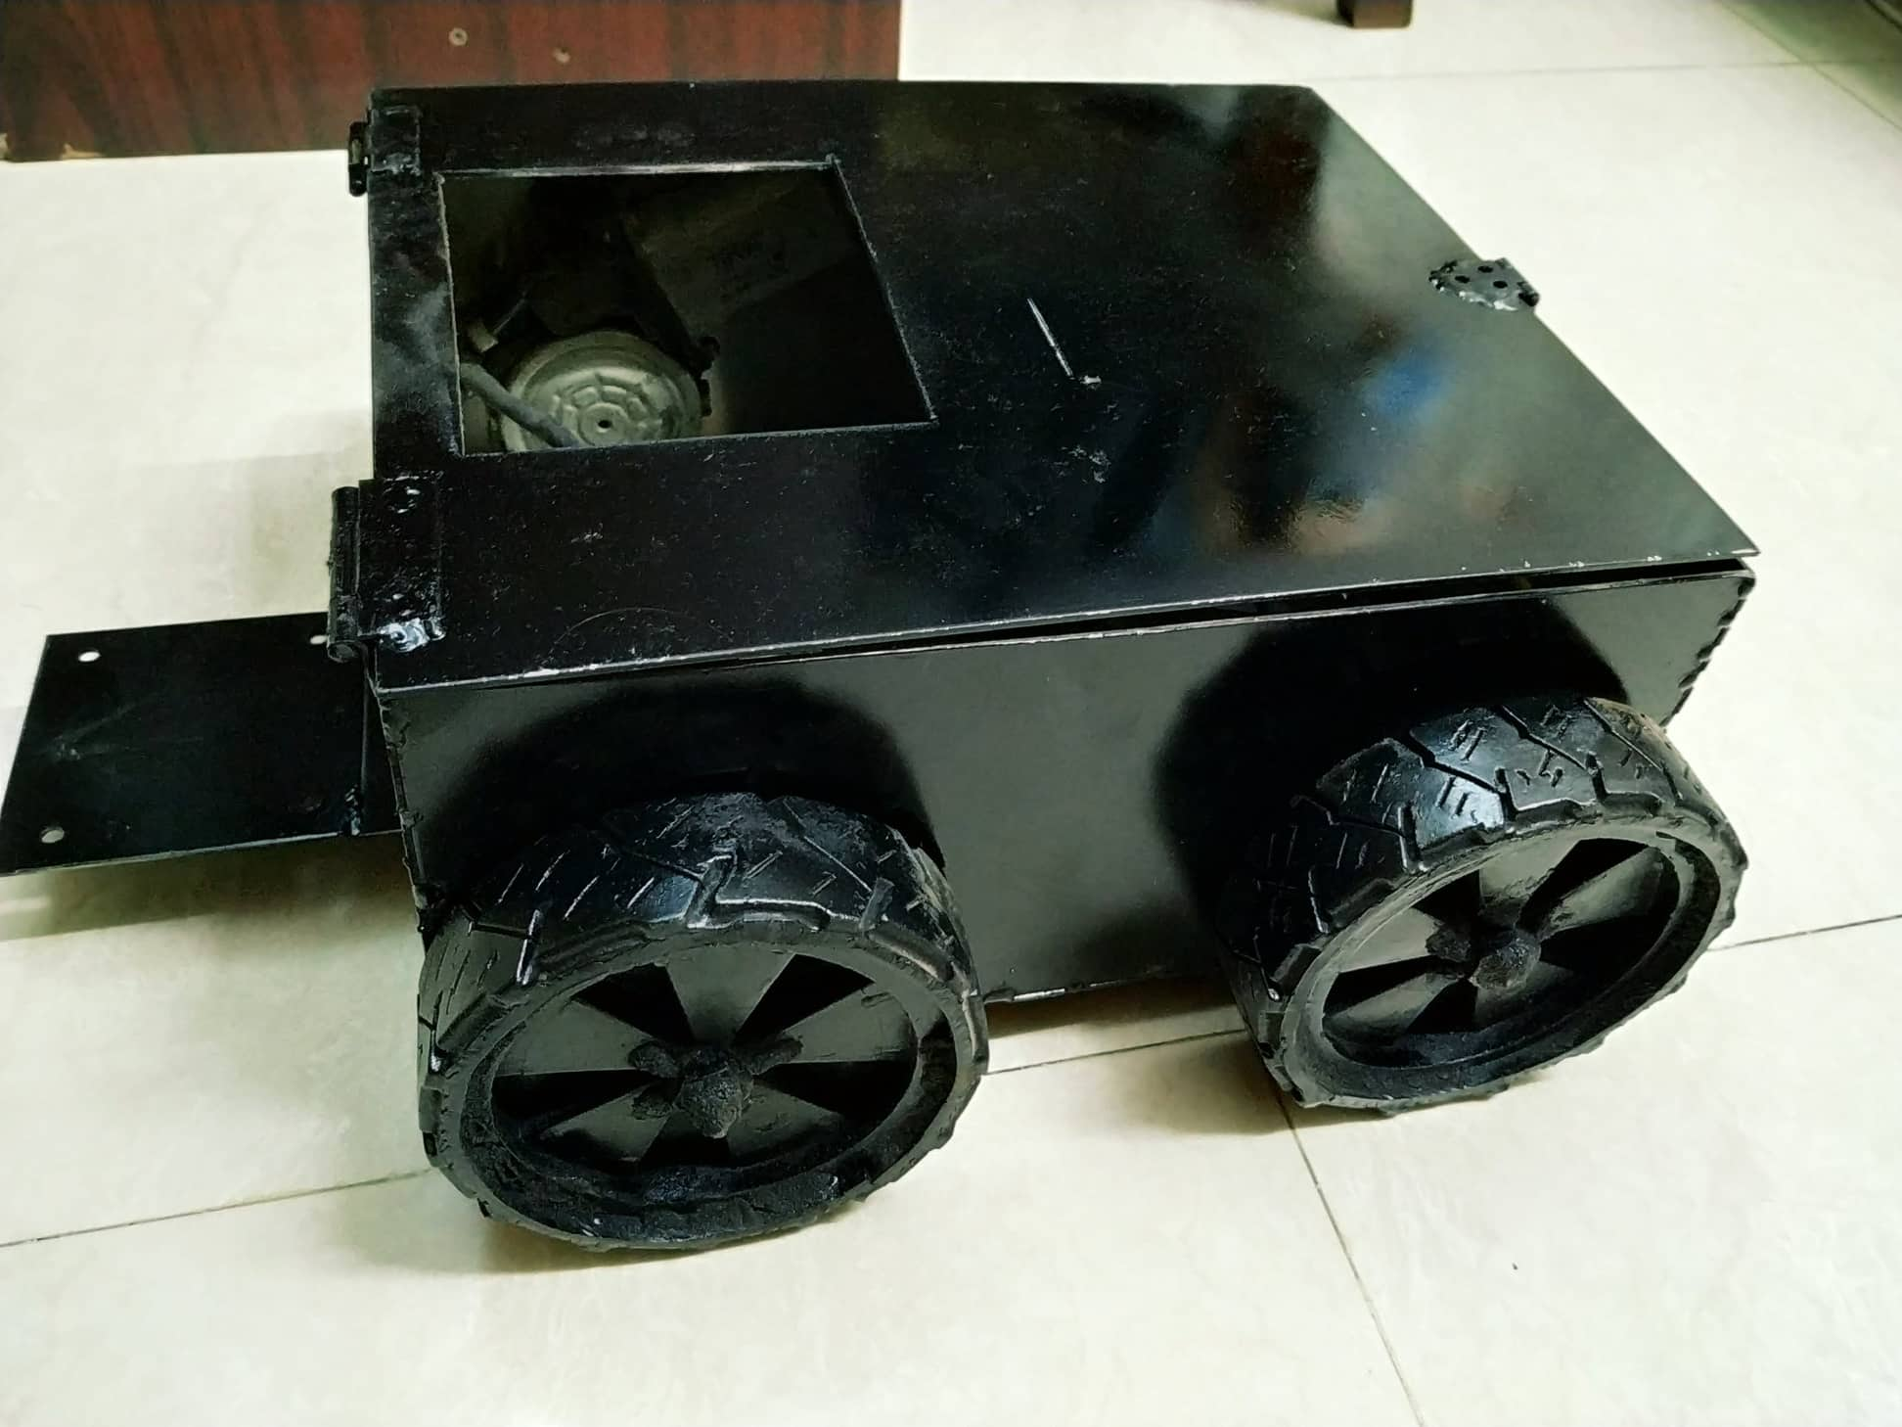

Fig: Robot Vehicle

These motors are so powerful that it helps the base of the robot to move over medium size pot holes and small rocks. There is a hollow opening on the top of the metallic body where a basket is fixed to a MG996R servo motor. The servo motor allows the basket to rotate on specific angles which helps to collect the categorized garbage.

**CONSTRUCTION OF THE ROBOT ARM**

There is a robotic arm on the front part of the robot vehicle. It is attached to the extended part on the front side. The robotic arm is built using MG996R servo motors and multi-function brackets. At first the base of the robotic arm is attached to a servo motor which helps the arm to rotate 180 degree. On the top the first servo motor is attached a custom built plate that can carry two servo motors which allows the robotic arm to make its first bend towards the ground. The second and third bend are similarly attached to two different servo motors which allows the robotic arm to bend further down towards the ground.

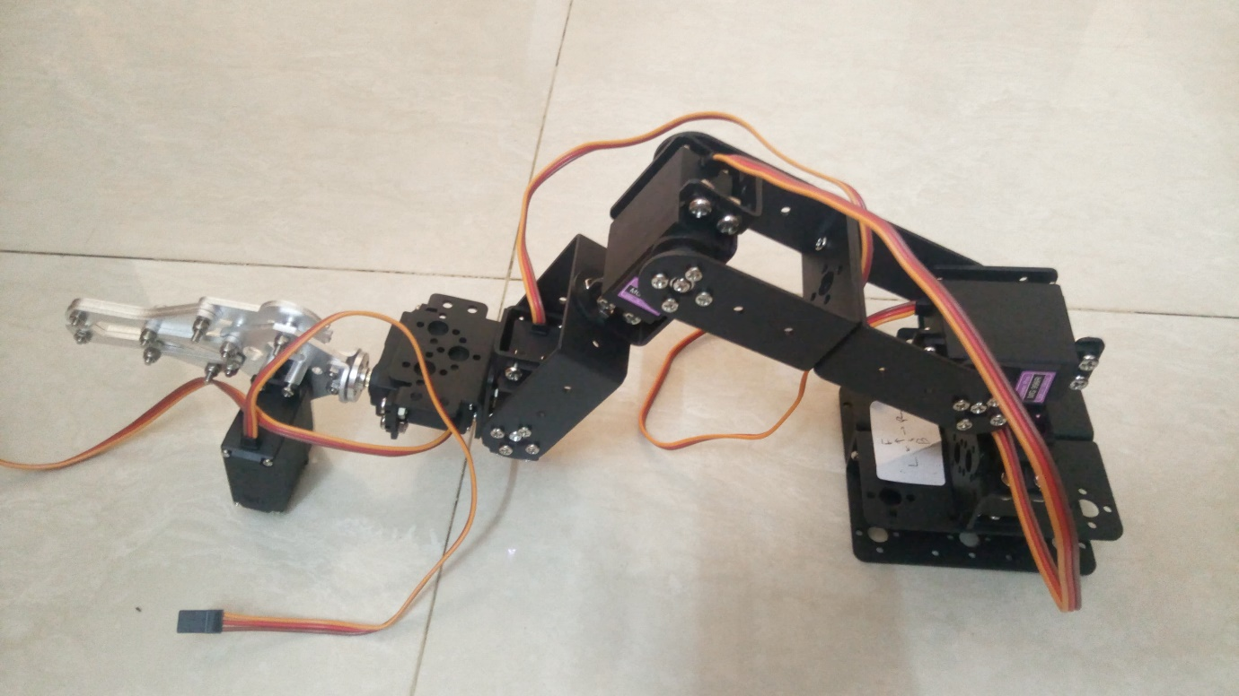

Fig: Robot Arm

Now a servo motor is attached to the base of a metallic claw which allows the claw to rotate 180 degree based on the position of the garbage. The last servo motor is attached to the metallic claw which helps the claw to open and close in order to grab the garbage.